Resource 1

Read the following tips and decide when you should do each. Tick the appropriate box: B (before), W (while) or A (after) listening. | B | W | A
1) Read the instructions carefully.
2) Transfer your answers from the question sheet to the answer sheet.
3) Multitask – listen, read and write simultaneously.
4) Check the number of words you can have for each answer.
5) Skim the task and underline keywords and headings.
6) Check the spelling of your answers.
7) Concentrate for the whole listening.
8) Check to see if you need to write a letter or a word for your answer.
9) Use shorthand to record possible answers.
10) Think of synonyms and paraphrases for keywords in tasks.
11) Keep your eye on the next two or three questions.
12) Identify the question and answer type.
13) Make notes of your answers on the question paper.
14) Don’t worry if you don’t understand some of the vocabulary.
15) Be aware of possible traps.
16) Notice the organization of the questions.
17) If you miss an answer, just move on to the next question.
18) Predict likely answers to questions.
19) Check the grammatical accuracy of your answer.
20) Listen carefully for plurals.
Resource 2

Section 1 (Questions 1‐7)

Before you listen:
- Skim the table in Section 1 and try to identify the topic of the listening.

- Read the instructions carefully. How many words can you use in each answer?

- Skim the organization of the questions as well as the language. How are the numbers organised?

- Look at the highlighted keywords and think of synonyms or paraphrases for them. Write your ideas on the question sheet.
- Look at each gap in Section 1 and identify the question and answer type. Write your ideas below:
Example: How much do tickets cost?
1
Number
2

3

4

5

6

7
f) Try to predict some of the answers to questions 1‐7.

1 | 5
2 | 6
3 | 7
4

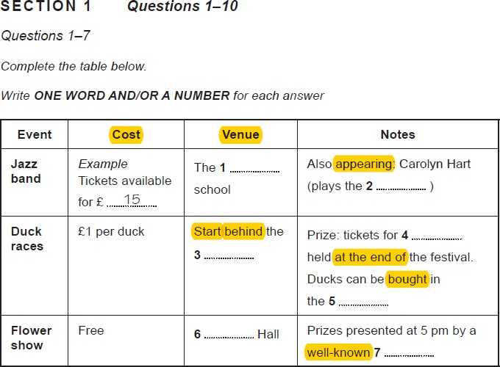

Resource 3

Section 1 (Questions 8‐10)

Before you listen:

- Read the instructions carefully. How should you answer these questions?

- Look at the highlighted keywords and think of synonyms or paraphrases for them. Write your ideas on the question sheet.

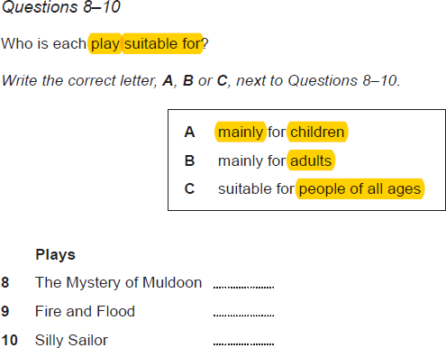

Resource 4

Section 2 (Questions 11‐16)

Before you listen:

- Skim Section 2 Questions 11‐16 below and identify the topic.

- Read the instructions carefully. How many questions and answer options are there?

- How do you answer?

- Look at the highlighted keywords and think of synonyms or paraphrases for them.

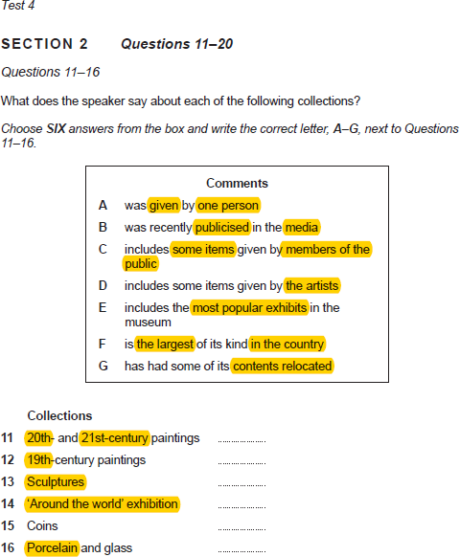

Resource 5

Section 2 (Questions 17‐20)

Before you listen:

- Read the instructions carefully. How should you answer these questions?

- How many answer options are there? How many questions are there?

- Highlight keywords and think of synonyms or paraphrases for them.

- Think about what kind of language you would need to describe the plan.

- Listen and write your answers on the sheet below.

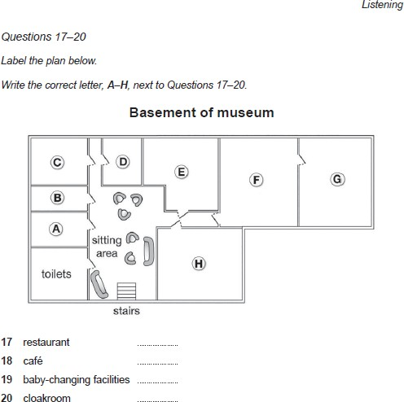

Mistakes Analysis

Write the question numbers that you got wrong in the appropriate box

Wrong spelling |  | Didn’t hear the answer / writing previous answer
Forgot the answer |  | Panicked!
Thought a distracter / trap was the answer |  | Wrote another word that was not on the recording
Wrote the right answer but in the wrong place |  | New vocabulary / didn’t understand meaning
Singular / plural error |  | Misheard the answer
Used wrong word formation |  | Left the answer blank

Discuss in groups

Which mistakes are you making the most?
How can you avoid making them again?

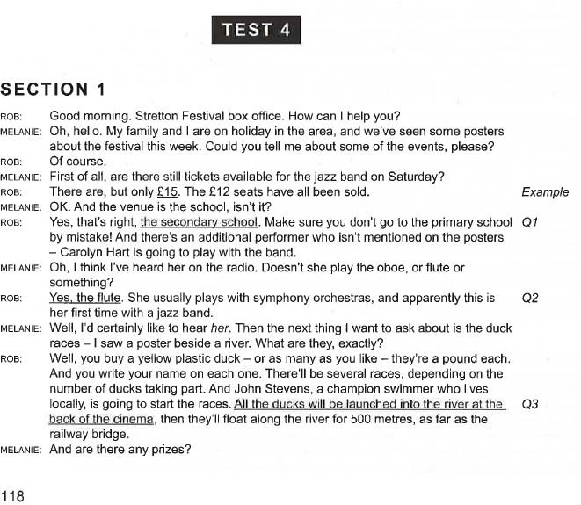

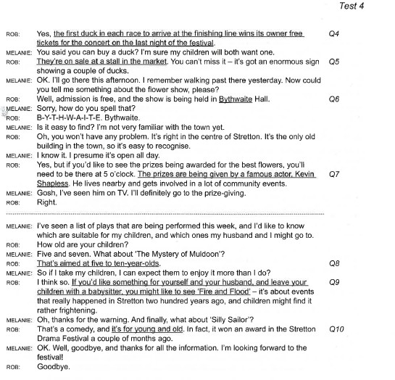
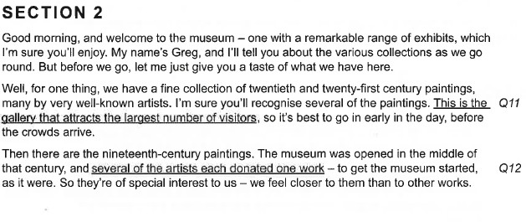

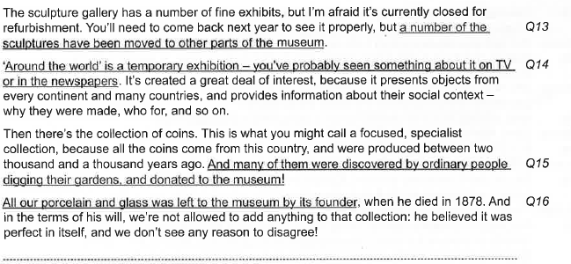
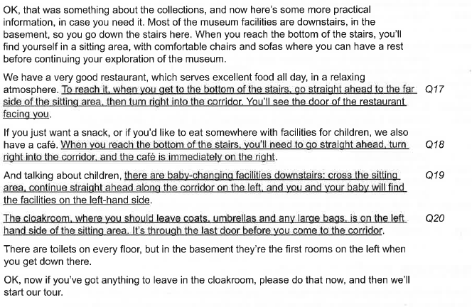

Resource 8

Extension Activity: Words for Dictation

Adults
Ages
Artists
Coins
Collections
Contents
Does
Facilities
Glass
Includes
Is
Items
Its
Members
Notes
Paintings
Prizes
Questions
Sculptures
Tickets

